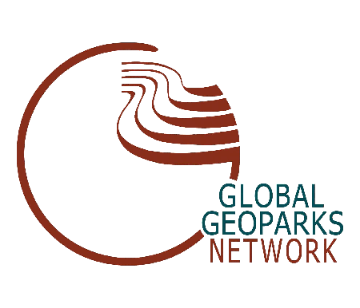

Geoparks and geoheritage; promoting geoheritage in Latin America.
28-29 May 2015.
Venue: Institute of Geography, Mexico City

In Mexico there is growing interest in the development of Geoparks as an initiative to promote awareness and education of the earth sciences, contribute to preservation of geological heritage, the conservation of nature, and promote geotourism as an alternative for local development, especially in marginalized indigenous communities.
Different groups, mainly from academic institutions, are developing proposals for the creation of Geoparks in Mexico and other Latin American countries. In the case of Mexico, the geopark concept has not been fully understood and this has resulted in a conceptual dispersion and clearly limited results. Furthermore, legislation, as in many other countries around the world, do not establish the importance of geodiversity and geoheritage among authorities, from federal to municipality levels.
Therefore, there is a clear need to disseminate geoparks as a strategy to help in the promotion of earth sciences, the protection of both natural and cultural heritage and its importance in contributing to local sustainable development through geotourism and other practices.

Objectives
- To know the Geoparks initiatives from the perspective of international organizations (UNESCO, ProGEO, European Geoparks Network-EGN-, Global Geoparks Network-GGN);
- To understand the regional and global initiatives on Geoparks (EGN and GGN);
- To know what is happening in Latin America regarding Geoparks;
- To raise attention and awareness of the importance of geoconservation and geoparks as a strategy for local economic development among authorities and nature managers;
- To contribute to the organization of national groups focused on the promotion and creation of Geoparks.
Participants
UNESCO
Patrick McKeever, Chief of Section, Earth Sciences and Geohazard Risk Reduction, Secretary of the IGCP, Division of Ecological and Earth Sciences, UNESCO
Denise Gorfinkiel, Ciencias de la Tierra y Desastres Naturales, Oficina Regional de Ciencias para América Latina y el Caribe de la UNESCO, Montevideo
Nicolas Zouros (Greece), EGN
Guy Martini (France), EGN
Luis Alcala (Spain, EGN-GGN)
Pablo Rivas (Spain, EGN-GGN)
Guy Martini (France, EGN-GGN)
Artur Sa (Portugal, EGN-GGN)
Martina Paskova (Czech Republic, EGN-GGN)
Kristin Rangnes (Norway, EGN Coordinator)
Nickolas Zouros (Greece, EGN Coordinator)

Contact Information:
José Luis Palacio (Instituto de Geografía UNAM) palacio@unam.mx

General Program
Day | Event
May 28
9.00-9.30 | Opening ceremony
9.30 -12.00 | Conferences
12.00-12.30 | Coffee break
12.30-14.00 | Mexican Aspiring Geoparks and projects
14.00-15.00 | Lunch
15.00-18.00 | Workshop
18.00-18.15 | Coffee break
18.15-19.00 | General Comments
May 29
9.00-12.00 | Conferences
12.00-12.30 | Coffee Break
12.30-14.00 | Latinamerican Aspiring Geoparks and projects
14.00-15.00 | Lunch
15.00-18.00 | Workshop
18.00-19.00 | General comments and conclusions

Registration dates: until May 20, 2015. Limited to 70 participants.

